SQL Statements – Hands on Document

**Create a table for the below schema structure and create the clustered and non clustered index for all the tables**

**i)**

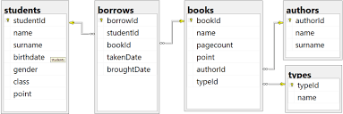

ii)

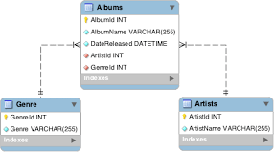

Page **2** of **2**

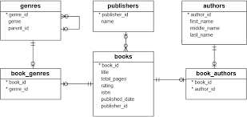

**iii)**